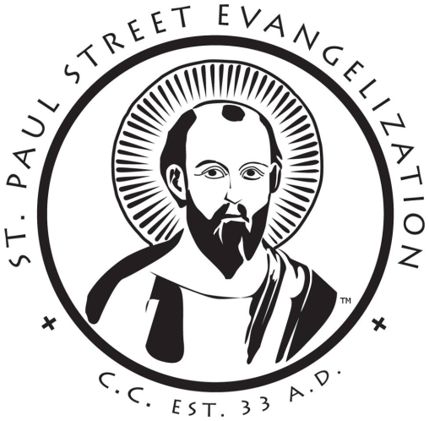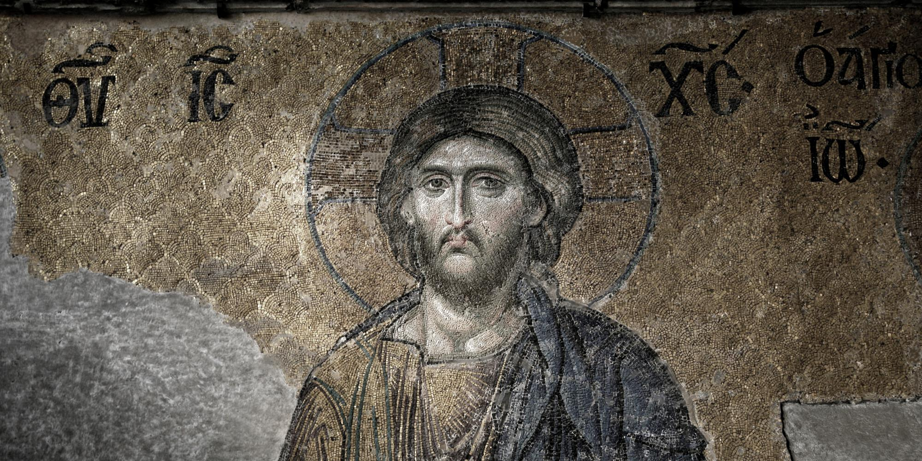

**St. Paul Street Evangelization** is a grassroots, non-profit Catholic evangelization organization, dedicated to responding to the mandate of Jesus to preach the Gospel to all nations by taking our Catholic Faith to the streets. We do this in a non-confrontational way, allowing the Holy Spirit to move in the hearts of those who witness our public Catholic presence.

As an on-the-street Catholic evangelization organization, St. Paul Street Evangelization provides an avenue for you to share the Person of Jesus Christ and the truth and beauty of the Catholic Faith with a hungry culture.

As we build a bridge of trust between the street and the parish members of our community are experiencing emotional, physical, and spiritual healing. Others are turning away from abortion and suicide as answers to their problems. Many people are returning to Mass or joining RCIA. We need your help and your prayers.

get involved stpaulse.com